In this assignment you will create a minesweeper game. This must be a Vue.js project using Typescript. To submit the completed test, create a public repository with GitHub and share the repository link with the person who sent you this assignment.

Create the minesweeper game implementing the following:

**When I start the game, the map should appear**

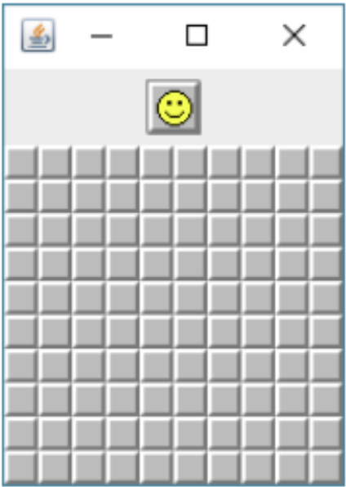

The indicator emoji should be smiling and every field is hidden

**When I click on a field it will be revealed**

The number appeared shows the number of mines in the surrounding 8 fields

**When I hit a field with 0 or any of its neighbours contains 0**

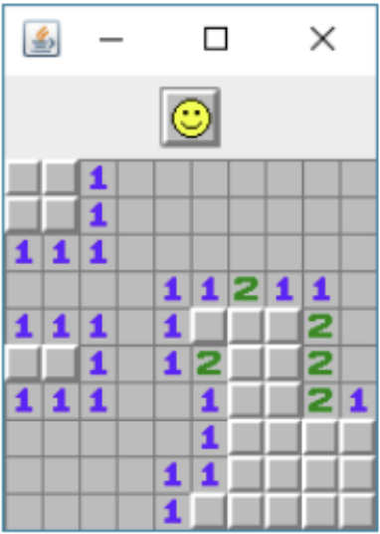

An “explosion” happens: all fields appear that are next to the connecting 0 value fields

**When I hit a field that contains a mine**

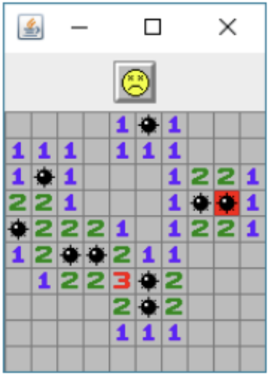

The indicator emoji should die and every field should be revealed.

**When ALL the fields appeared but the ones with the mines**

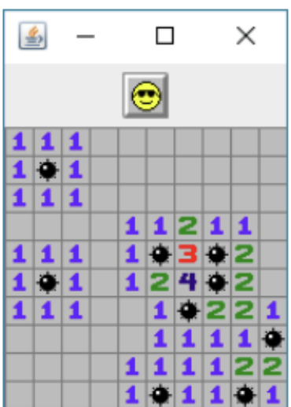

The indicator emoji should put on glasses and every field should be revealed

**When I click on the indicator emoji the game should restart**

Every field should be hidden and the mines should be randomly placed again